Interacting with Deployed Smart Contracts on Hyperledger Besu

* Code out Email.sol; a smart contract which stores, updates and emits the email address of the respective user

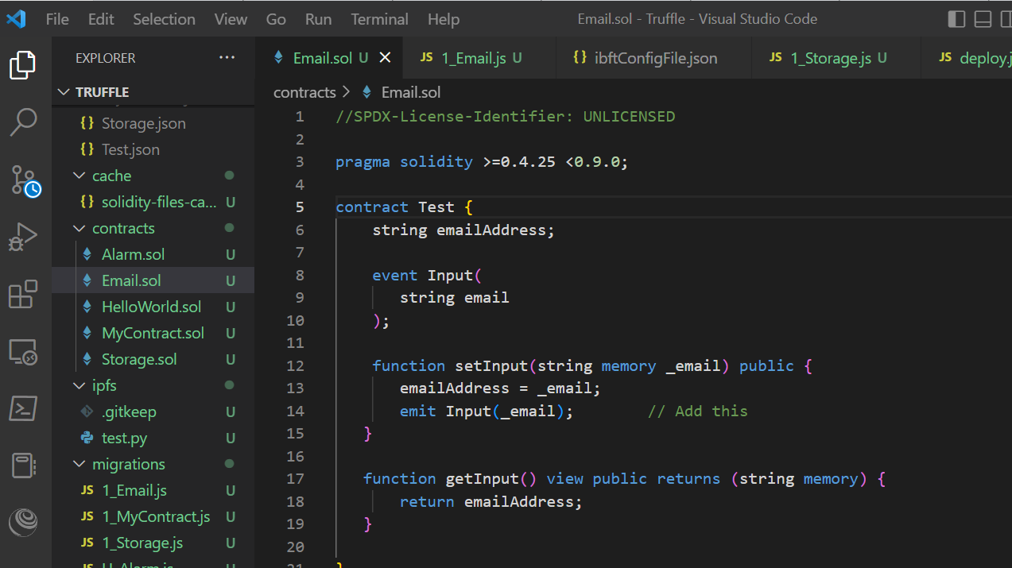

* Deploy Email.sol with Truffle
  + Run the Private Blockchain

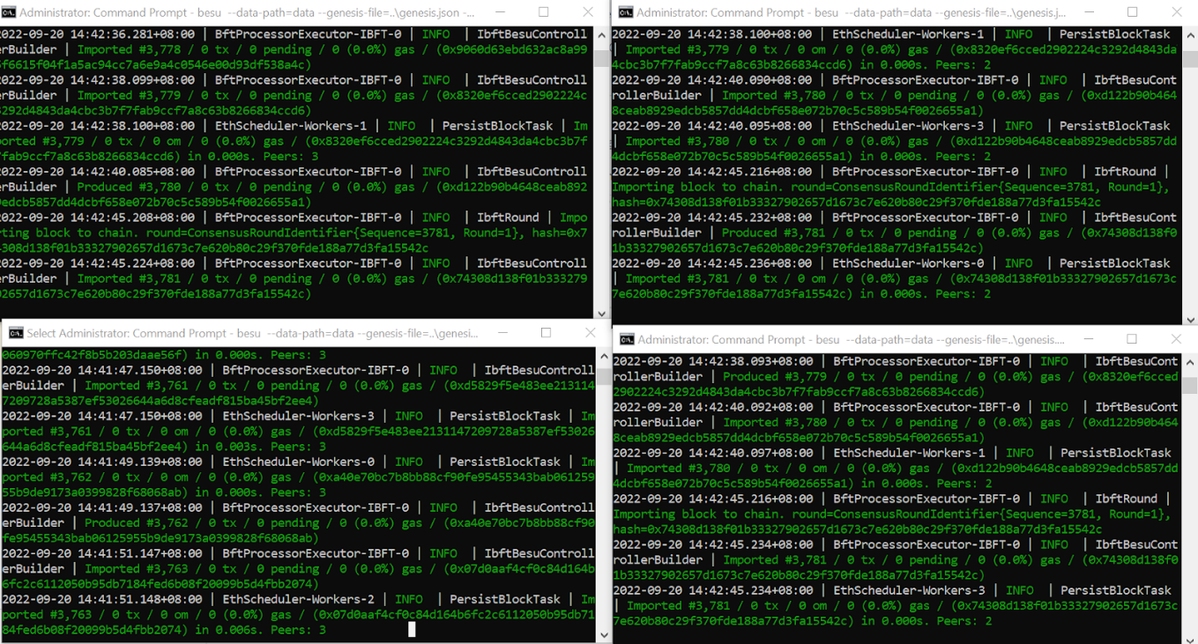

* + Type the following commands in command prompt; truffle migrate –network besuWallet

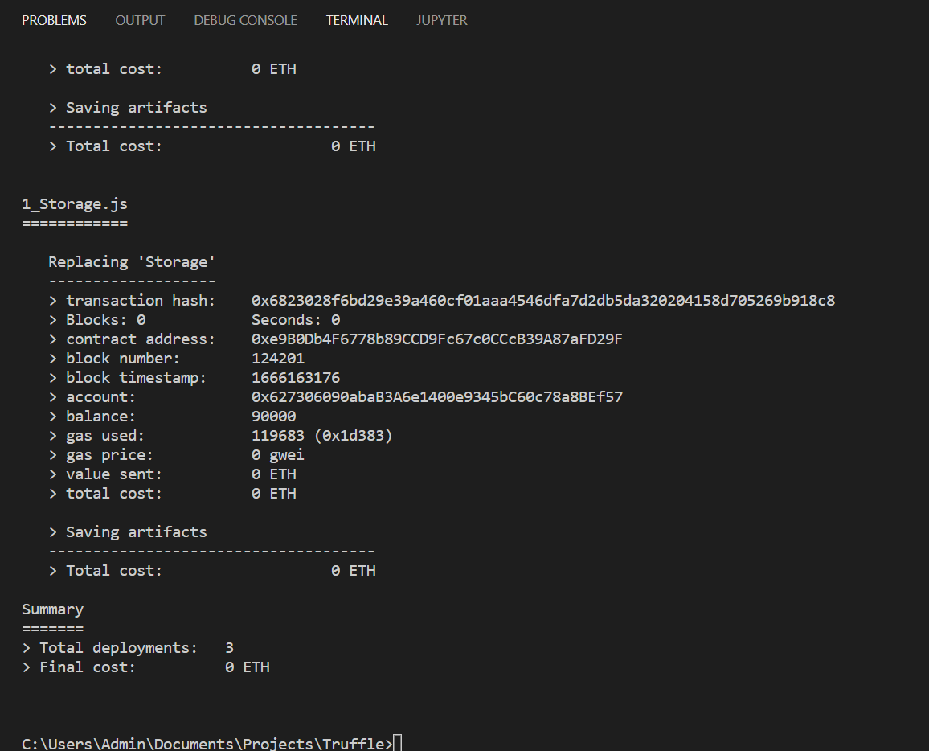

* Interact and Listen to past events with Test.sol with Web3.js
  + Install Web3 npm package

npm **install** web3

* + Create a new Javascript file called email.js and type the following codes

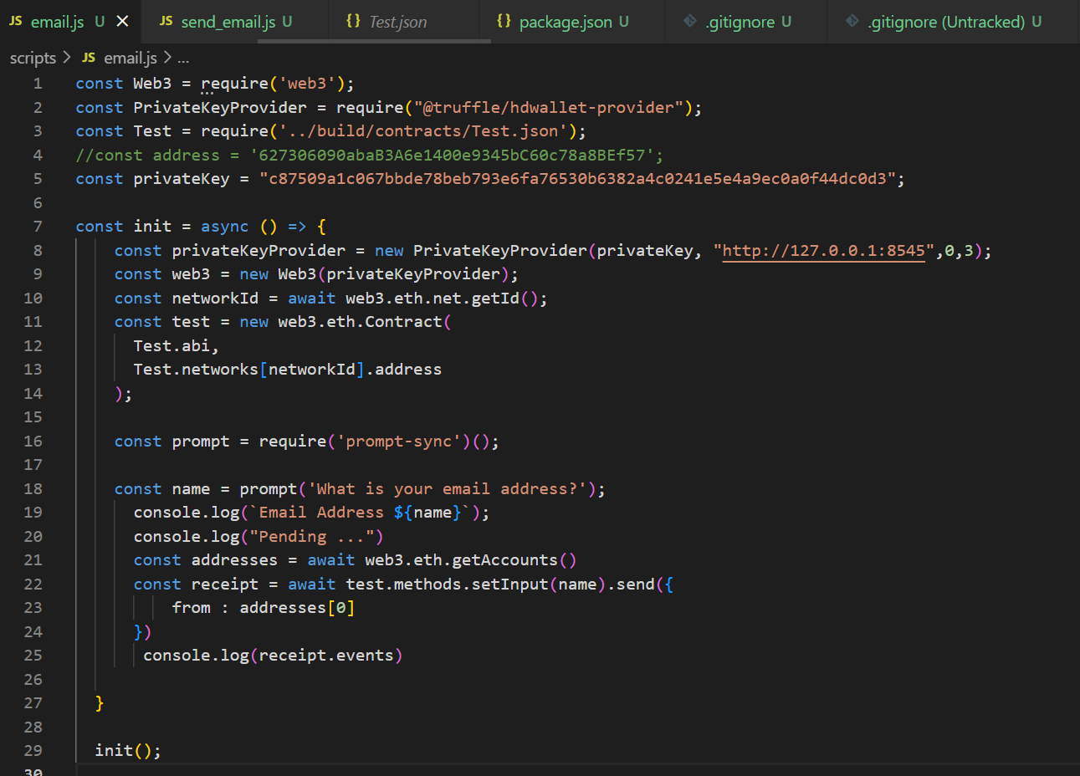

* + Create a new Javascript file called send_email.js and type the following codes

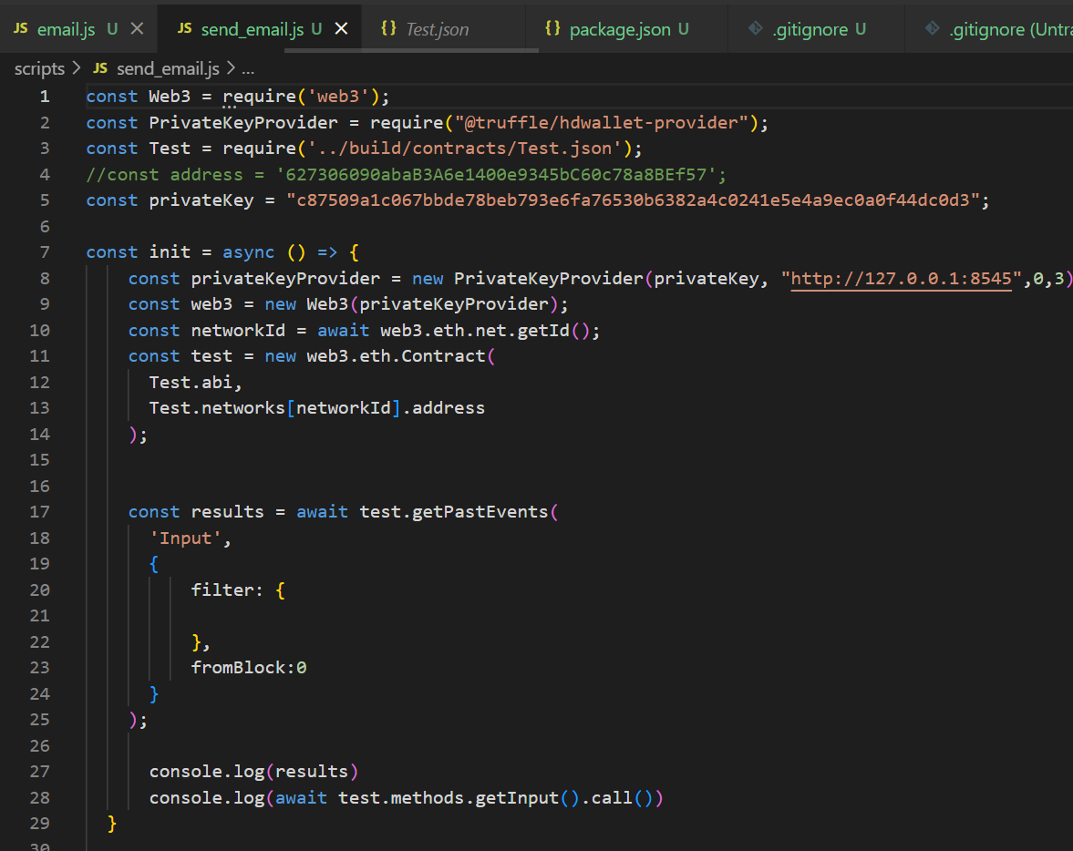

* Retrieve and receive the event log from the separate javascript file
  + Run both the javascript files

1st Input

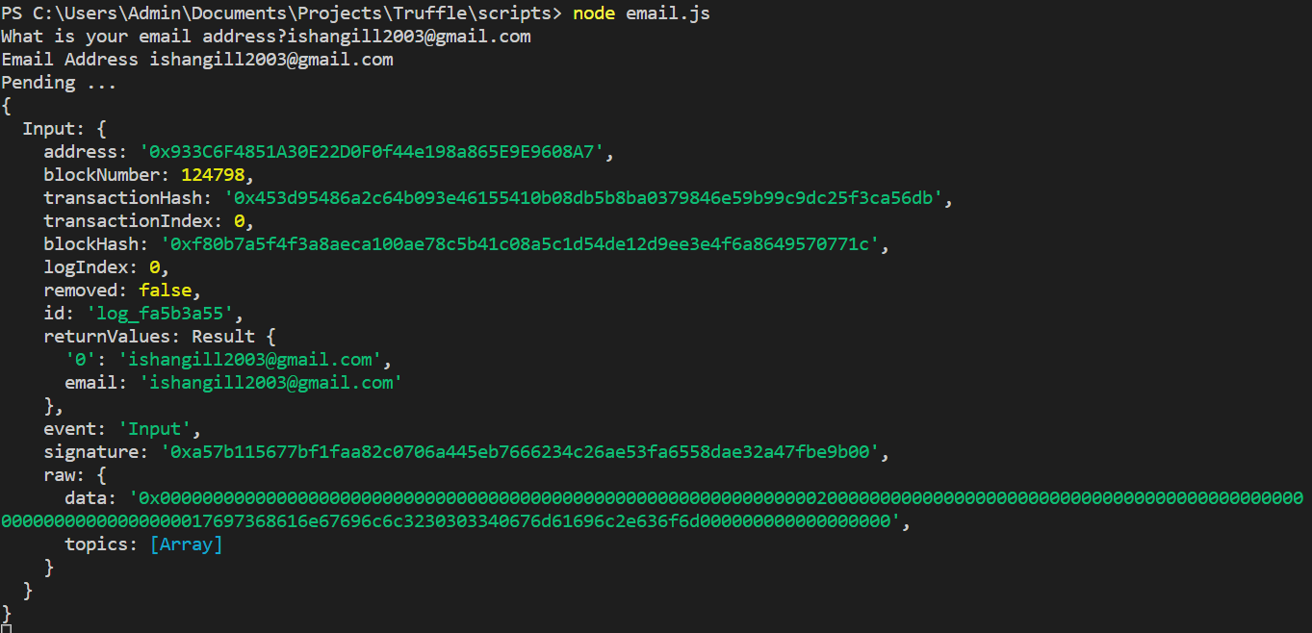

2nd Input

